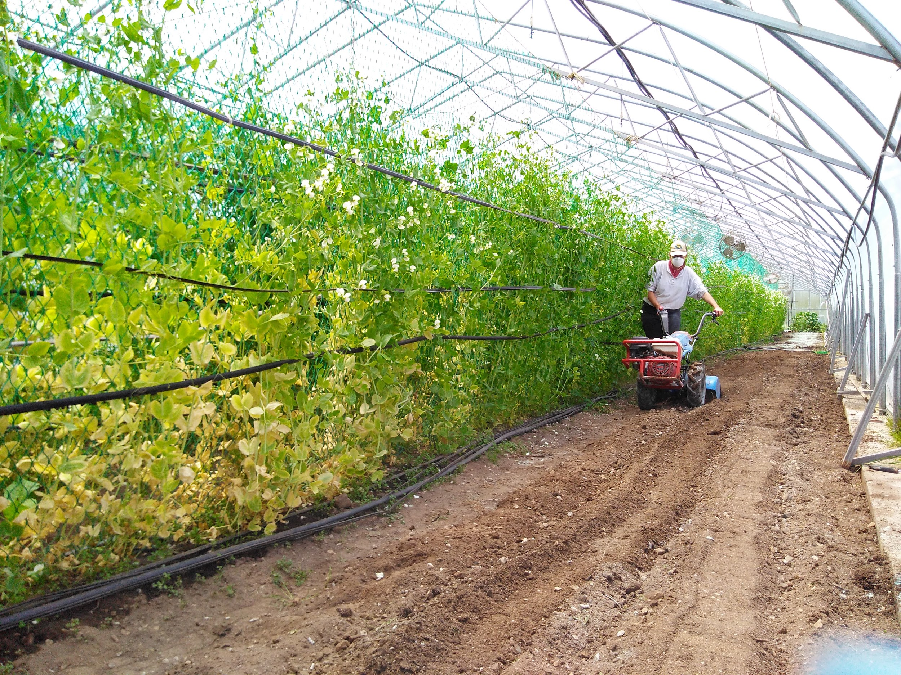
Life continues without Tom Loader on The Organic Farm. Before leaving, Tom taught Rachel, the SOIL apprentice, the rudiments of weighing and spreading amendments (chicken pellets, kelp, and green sand which make the soil strong and healthy), as well as the usage of the BCS tiller. The lady is a beast!

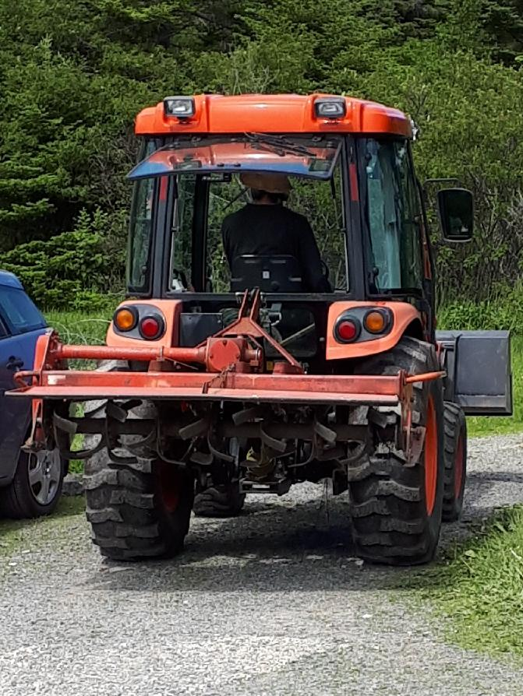

Marc, the Farmstay, was given a crash course in tractor operation, and he can now be seen in his Gilligan’s hat buzzing around the farm delivering large quantities of mulch to the newly planted orchard and drilling post holes for new bean and pea arbors. Marc is much more vocal than Tom on the tractor, always tooting on the horn at whoever is in the fields as he drives by.

Peas have been most prolific out of Greenhouse 5, with Rachel doing early morning harvests this past week and Mike going in at all hours of the day despite the heat from the sun to stay on top of them. The snow peas in particular have to be picked at just the right moment. We hope you’ve enjoyed them - sadly the snow peas will be done this week and the sugar snaps next week. Their remnants will be cleared and replaced with runner and pole beans.
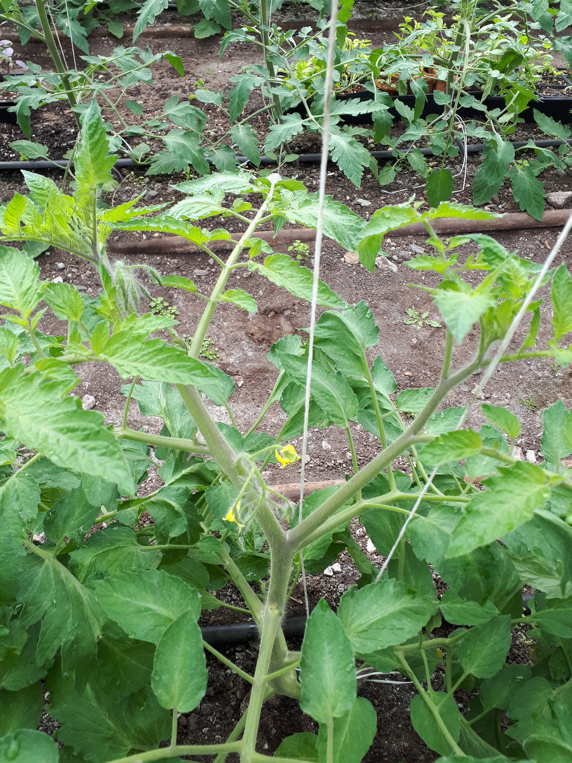
In other greenhouse news, the second leader vines on our tomatoes in greenhouse 1 have begun to reveal themselves. The second leader is the sucker immediately below the first blossomed fruit branch. In the past The Organic Farm has used only one leader but this meant that plants needed to be dropped as they grew taller and taller towards the ceiling. Mike’s thought is that with two leaders the plants will not grow so tall. Marc, who spent a lot of time with the tomatoes last year, is concerned about the extra foliage and possible lack of airflow. Rachel, new to greenhouses and the care of tomatoes, is just enjoying the aroma of the plants and the satisfying snap of suckers breaking off.

Out in the fields planting continues. Our first crops of arugula and spinach are done, and the beds will shortly be cleared and replanted: arugula will replace spinach and vice-versa. Squash of all varieties was planted this past week. An experiment of planting into an old bed of well composted horse manure is underway. And… the weeds! Oh, those lovely weeds! Marc has generally been the Weed Man but as he is now split on tractor duty, others are attempting to fill the gap. If anyone desires to volunteer on our weed gang, we would greatly appreciate the extra hands!

We hope you’ve enjoyed your first two CSA bags and are not sick of Chinese cabbage! On Saturday Rachel crafted a CSA bag-inspired meal: Chinese cabbage, arugula, green onion, and radish stir fry with chickpeas and ginger peanut butter sauce. Marc and Rachel are mad for ginger, so she went heavier on it than the following recipe calls for. A couple family members found it spicy but still enjoyable. Mike turned it into a complete meal with some melted cheddar cheese added on top. The sauce can easily fit any of the greens you receive this week if you’re in need of inspiration.

But now this writer is going to make rhubarb squares. Enjoy!

Peanut Butter Sauce
1 cup onion, chopped
1 cup peanut butter
1 tbs honey
¼ tsp cayenne
1 lemon, juiced*
½ tsp ginger root, finely grated*
1 bay leaf
1 tbsp cider vinegar
3 cups water
1 tsp salt
1 dash tamari
2 tbsp butter

Lightly fry onion in the butter. Once softened, add peanut butter, honey, cayenne, and lemon juice. Once hot through and combined, bung in the rest of the ingredients, cooking until boiled. The longer you let it stew, the stronger your flavour.
*Concentrated lemon juice will work, a shot or two
*Rachel puts in several tablespoons of ginger

